**Production Possibility Curve**

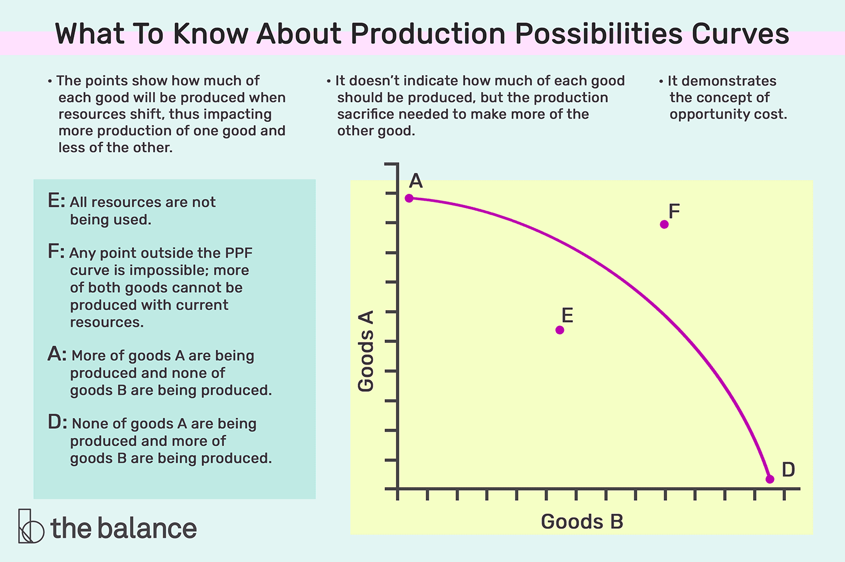

If you buy 100 shares of East African Breweries stock (i) To what are you entitled? {3 marks} (ii) What is the most money you can make on this investment over the next year? {2 marks} (iii) If you paid KES180 per share, what is the most money you could lose over the year? {2 marks}

**(i) To what are you entitled?**

When you buy shares (or stock) in a company, you are buying a piece of ownership in that company. As a shareholder of East African Breweries, you are entitled to:

1. **Dividends**: If East African Breweries declares dividends, you are entitled to receive your proportionate share of those dividends based on the number of shares you own.
2. **Voting Rights**: Typically, common shareholders have the right to vote on certain company matters, such as electing members to the board of directors or approving major corporate actions. Your voting power is proportional to the number of shares you own.
3. **Capital Appreciation**: If the value of East African Breweries increases, the value of your shares may also increase, leading to potential capital gains if you decide to sell your shares at a higher price than you bought them.
4. **Information**: As a shareholder, you have the right to access certain company information, such as annual reports and financial statements, which can help you make informed decisions about your investment.

**(ii) What is the most money you can make on this investment over the next year?**

The most money you can make on this investment over the next year would be if the value of East African Breweries stock rises to its maximum potential (which is theoretically unlimited) and you sell at that high price. Additionally, you would add any dividends received during the year.

However, predicting the exact maximum value is speculative and depends on various factors like company performance, market conditions, and broader economic factors. In reality, there's no fixed upper limit to how much a stock can appreciate within a year.

**(iii) If you paid KES180 per share, what is the most money you could lose over the year?**

If you paid KES 180 per share for 100 shares, your total investment would be:

Total Investment=100× *KES* 180= *KES* 18,000 Total Investment=100×*KES*180=*KES*18,000

The most money you could lose on this investment is the entire amount you invested if the stock becomes worthless (i.e., the company goes bankrupt and the stock value drops to zero). So, the maximum potential loss is KES18,000.

However, it's worth noting that while stocks can decrease in value, it's relatively rare for established companies to see their stock value drop to absolute zero.

**(i) Calculate the equilibrium level of income**

The equilibrium level of income is achieved when aggregate demand (AD) equals aggregate supply (AS). In the context of the Keynesian cross model, aggregate supply is simply the national income, �*Y*, and aggregate demand is the sum of consumption, investment, government expenditure, and net exports.

Given: �=0.6��*C*=0.6*Yd* �=200*I*=200 �=400*G*=400 �=100*X*=100 �=0.3�*M*=0.3*Y*

Where:

* �*C* is consumption expenditure
* �*I* is investment expenditure
* �*G* is government expenditure
* �*X* is exports
* �*M* is imports

Disposable income, ��*Yd*, is the income left after taxation. Given that the rate of taxation is 50%, we have: ��=�−0.5�=0.5�*Yd*=*Y*−0.5*Y*=0.5*Y*

Substituting this into the consumption function: �=0.6(0.5�)=0.3�*C*=0.6(0.5*Y*)=0.3*Y*

The aggregate demand (AD) is: ��=�+�+�+(�−�)*AD*=*C*+*I*+*G*+(*X*−*M*) ��=0.3�+200+400+(100−0.3�)*AD*=0.3*Y*+200+400+(100−0.3*Y*) ��=0.3�+700−0.3�*AD*=0.3*Y*+700−0.3*Y* ��=700*AD*=700

At equilibrium, ��=�*AD*=*Y*: �=700*Y*=700

Thus, the equilibrium level of income, �*Y*, is KES 700 million.

**(ii) Calculate the equilibrium level of consumption expenditure**

Using the consumption function: �=0.3�*C*=0.3*Y* �=0.3(700)=210*C*=0.3(700)=210

The equilibrium level of consumption expenditure is KES 210 million.

**(iii) Calculate the fiscal budget surplus/deficit at equilibrium level of national income**

The fiscal budget balance is the difference between government expenditure and tax revenue. Tax revenue is 50% of the national income.

Tax revenue = 0.5 * 700 = 350

Fiscal budget balance = Tax revenue - Government expenditure = 350 - 400 = -50

There is a fiscal budget deficit of KES 50 million.

**(iv) Calculate the current account surplus/deficit at equilibrium level of national income**

The current account balance is the difference between exports and imports.

��=�−�*CA*=*X*−*M* ��=100−0.3(700)*CA*=100−0.3(700) ��=100−210*CA*=100−210 ��=−110*CA*=−110

There is a current account deficit of KES 110 million.

**(v) State any three utilities of GDP as a statistic to a data scientist:**

1. **Economic Health Indicator**: GDP provides a snapshot of a country's economic health and performance, allowing data scientists to analyze economic trends and forecast future growth.
2. **Policy Evaluation**: By analyzing GDP data, data scientists can assess the effectiveness of economic policies and recommend changes.
3. **Comparative Analysis**: GDP allows data scientists to compare the economic performance of different countries, regions, or sectors, aiding in decision-making processes for businesses and policymakers.

**(vi) Given the shortfalls of measuring GDP, what solutions would you propose as a data scientist to solve these shortfalls?**

1. **Incorporate Non-Market Activities**: Traditional GDP calculations often exclude non-market activities, such as household work or volunteer services. Data scientists could develop models to estimate the value of these activities and include them in GDP calculations.
2. **Adjust for Income Inequality**: GDP does not reflect income distribution. Data scientists could use tools like the Gini coefficient alongside GDP to provide a more comprehensive view of economic well-being.
3. **Consider Environmental and Social Factors**: GDP does not account for environmental degradation or social well-being. Data scientists could develop alternative metrics, such as the Genuine Progress Indicator (GPI), which adjusts GDP by considering environmental and social factors.

Note: The calculations above are based on the Keynesian cross model and the given data. Actual economic scenarios might require more complex models and additional data.

You wish to disabuse the notion that financial markets in Kenya are too small to matter using data. As an initial step, you first wish to establish the connection between financial markets and the economy in general using a list of channels. State any five connections between financial markets and the macroeconomy that would be contained in your list

ChatGPT

Certainly! Financial markets play a pivotal role in the macroeconomy, and their significance extends beyond just the size of the market. Here are five key connections between financial markets and the macroeconomy:

1. **Capital Allocation and Investment**:
   * Financial markets facilitate the efficient allocation of capital to businesses and entrepreneurs. By channeling savings to investments, they support capital accumulation, which is crucial for economic growth. A well-functioning financial market can help ensure that resources are allocated to the most productive ventures.
2. **Risk Diversification and Management**:
   * Financial markets offer a variety of instruments that allow individuals, businesses, and governments to manage and diversify risks. This risk management capability can stabilize the economy by reducing the adverse impacts of economic shocks.
3. **Liquidity Provision**:
   * Financial markets provide liquidity to investors. This means that assets can be quickly converted into cash without significant loss in value. High liquidity can boost investor confidence and encourage more investment, which in turn supports economic growth.
4. **Price Discovery**:
   * Financial markets play a crucial role in determining the prices of assets and commodities based on supply and demand dynamics. This price discovery process provides valuable information to businesses and policymakers about the state of the economy and future expectations.
5. **Transmission of Monetary Policy**:
   * Financial markets are the primary channels through which central bank policies (like interest rate changes) are transmitted to the broader economy. For instance, when a central bank raises interest rates, it can lead to changes in borrowing costs, asset prices, and consumer spending, all of which can influence economic activity.

By highlighting these connections, one can emphasize the importance of financial markets in Kenya and their role in shaping the macroeconomic landscape, irrespective of their perceived size.